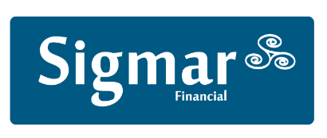 Sigmar Recruitment Consultants Limited
13 Hume Street, Dublin 2, Ireland
Tel: (+353) 1 4744600
CITCO FUND SERVICES Fax: (+353) 1 4744641
Email: financial@sigmar.ie
Web: www.sigmar.ie
Interviewed by: |  | Submitted:

Name:
Position applying for:
Qualifications:
Notice Period:
Interview availability:
Relevant Skills:

Comments:

